Charles H. Townes: The Light Fantastic
Lasers have transformed medicine, computers, telecom, and electronics

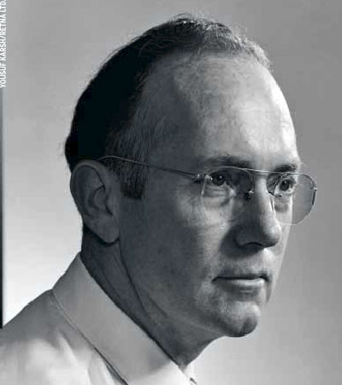

The story of the laser begins with some eye trouble. It was 1937, and Charles H. Townes, a first-year grad student at California Institute of Technology, faced a tough decision: pursue theoretical physics, a field then electrified by Einstein's ideas, or go into experimental physics, where he would build machines to test theories.
"My eyes were bothering me," Townes recalled in a recent phone interview. "A doctor said it was all the reading I was doing." Working with instruments instead of formulas, he figured, would save his sight. That choice took him down a path others had overlooked -- one that led to devices that emit brilliant beams of light. "Initially, many theoreticians doubted this was possible," he says, including Niels Bohr and computer pioneer John von Neumann. Townes patented the laser in 1959 and won a Nobel prize five years later.
He was educated in the presence of greatness. At CalTech, Townes rubbed shoulders with J. Robert Oppenheimer, Nobel laureate Linus Pauling, and a half-dozen other future Nobel winners. With a newly minted PhD, he toiled during the war years at Bell Labs beside transistor co-inventors William B. Shockley and Walter H. Brattain, developing early radar systems.
Townes joined Columbia University's faculty in 1948 to research how microwaves might help reveal the structure of molecules. All he really sought was a new scientific tool, but what he invented revolutionized science. In 1951 he realized that stimulating molecules with microwaves -- and amplifying the effect in a special chamber -- could trigger a chain reaction leading to the emission of an unusually pure, concentrated beam of radiation. Three years later, Townes and his grad students fired up a machine that produced the desired beam. They called it a MASER, for microwave amplification by stimulated emission of radiation. Townes shared the 1964 Nobel for it with two Soviet scientists who were doing related research.
In 1958, Townes and his brother-in-law, Arthur L. Schawlow, adapted his theory to show that visible light could replace microwaves. But the first lasers were built by others, and Townes's laser patent was later challenged by an ex-student, Gordon Gould.
At 89, Townes is still doing research -- and his eyes are just fine. In recent years he has focused on astronomy, using lasers to help combine images from distant telescopes, effectively creating a huge virtual lens. Although the killer applications didn't materialize for many years, his lasers have transformed medicine, telecommunications, consumer electronics, and computing, and they're part of the emerging toolkit for nanotech. Laser surgery, Townes notes, has even saved the sight of some of his friends.

By Adam Aston
http://www.businessweek.com/magazine/content/04_31/b3894027_mz072.htm

